**THE EVENTS INDUSTRY FORUM LTD**

**RESOLUTION 0001: ADOPTION OF NEW ARTICLES AND MEMORANDUM**

At a meeting of the Board of Directors held online on 4th February 2022 it was resolved by majority that new Articles and Memorandum should be adopted.

Those voting in favour were:

Steve Heap

Paul Hooper

Carl Hagemann

Jim Winship

Mark Laurie

Eric Stuart

Those voting against were:

Susan Tanner

**Signed Steven Heap (Chair)** 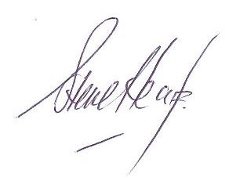



**Date: 28/03/2022**